1. Download sonarqube from <https://www.sonarqube.org/downloads/> and install.
2. Download sonar scanner from <https://docs.sonarqube.org/display/SCAN/Analyzing+with+SonarQube+Scanner> and install it.

In the jenkins dashboard, click on manage jenkins -> configure system.

In the SonarQube server section,

Enter Name, server url, server authentication token (which will get from sonarqube dashboard Myaccount -> security).

Click **Apply** and **Save.**

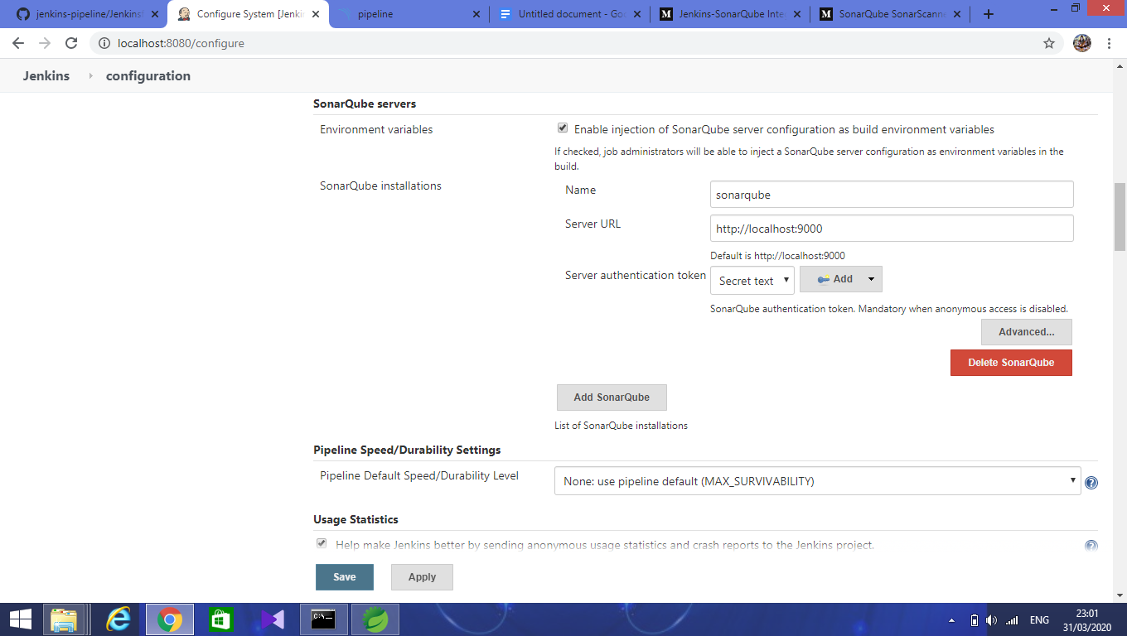

Next in the jenkins dashboard, click on manage jenkins -> Global tool configuration.

In SonarQube Scanner, enter the name and set the home path of the sonar scanner.

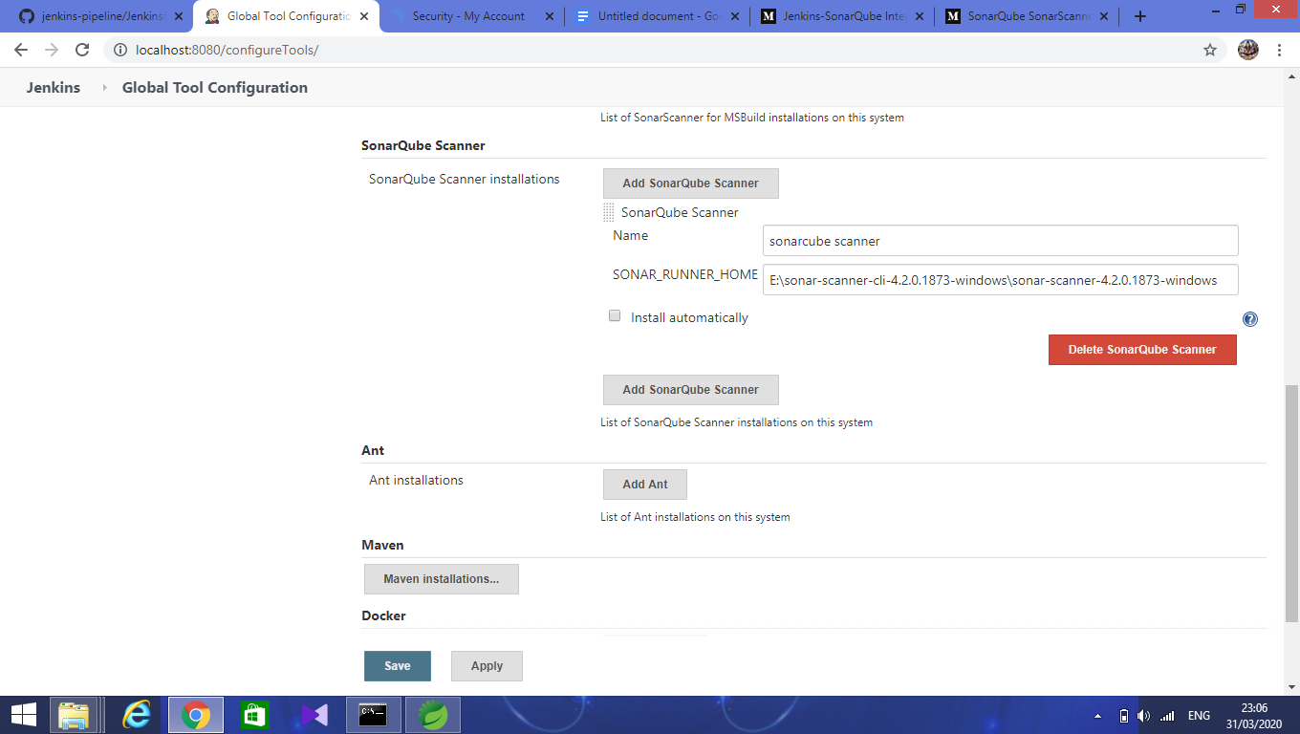

Next, create a jenkins job as shown below:

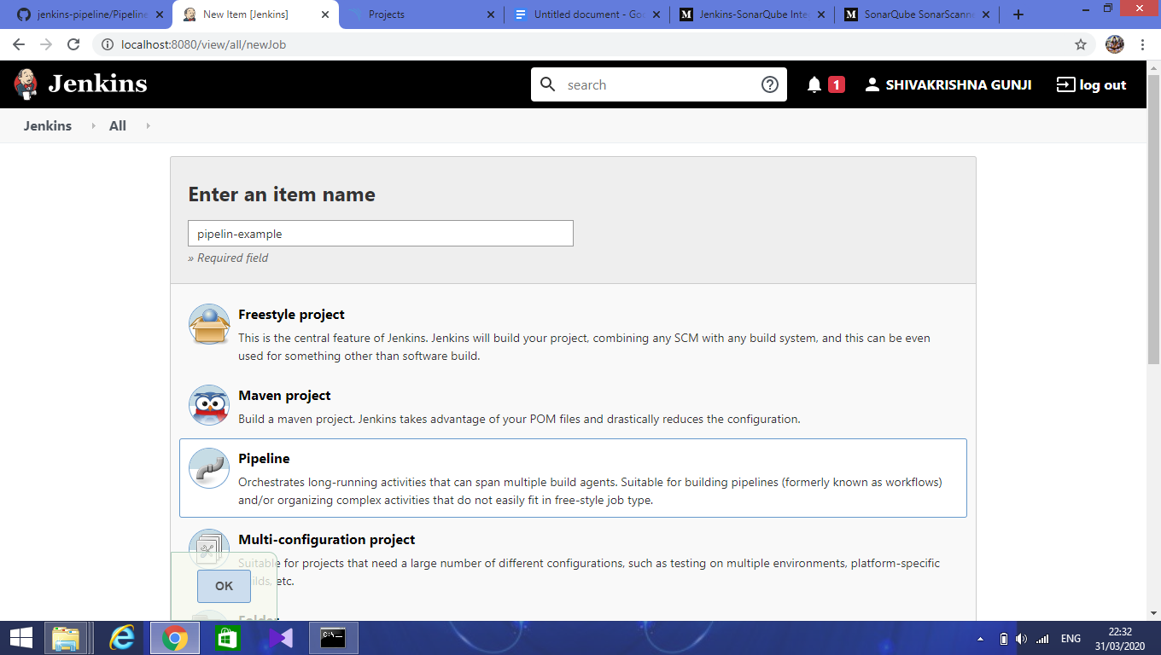

Enter name of job and select **pipeline** as shown

Click ok to continue.

Next, in the pipeline section,

Select option **Pipeline script from scm** from **Definition**.

In scm, select **Git**

In **Repository url** enter git repository link as shown below:

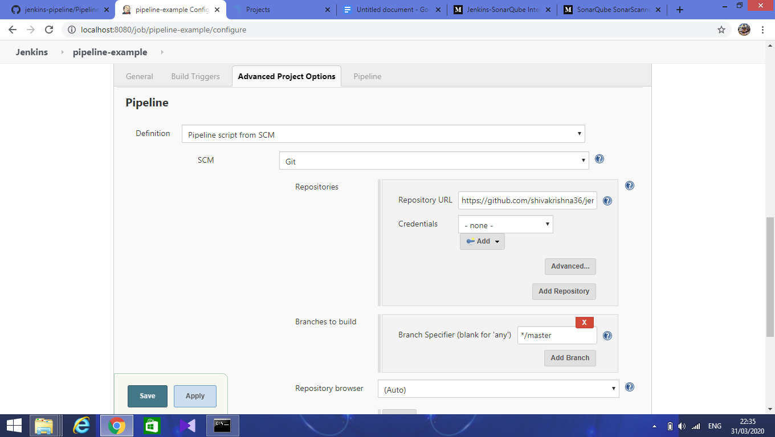

Next, enter script path

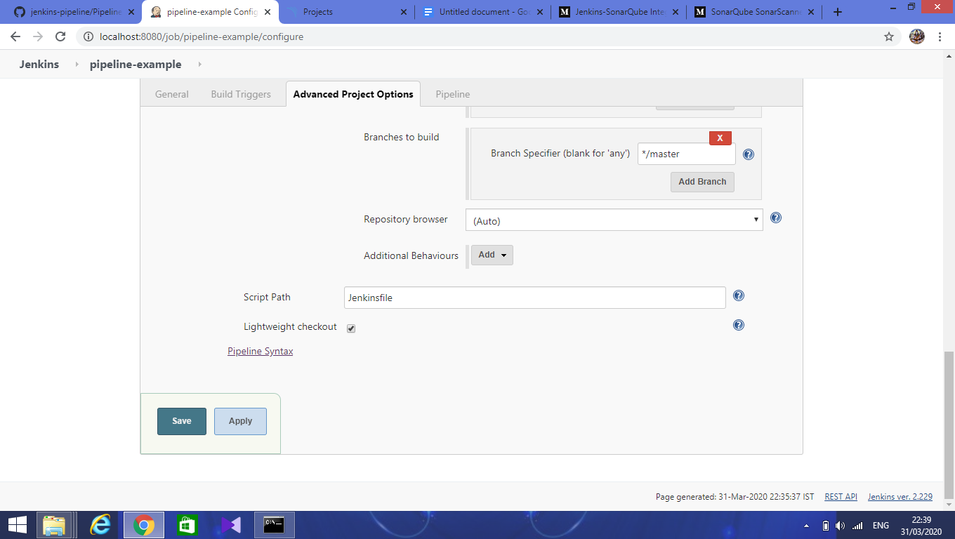

Click on **Apply** and **Save.**

Next in the maven project, create a file with the name **Jenkinsfile** as shown below:

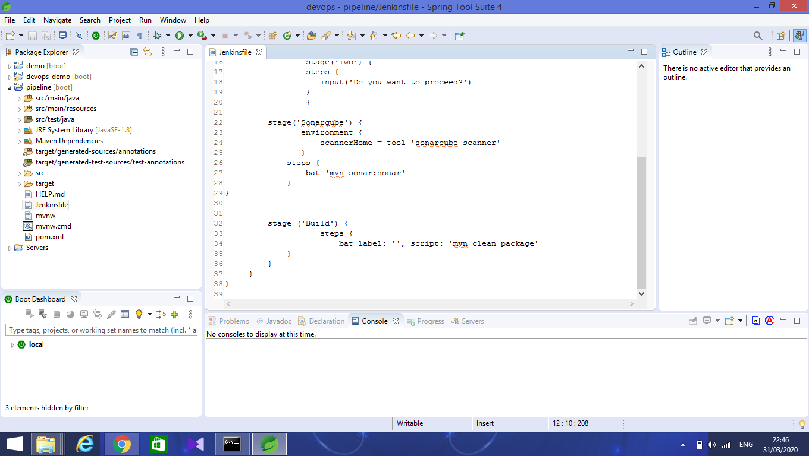

This file has a **Declarative pipeline** script for jenkins job configuration.

It has various stages like **Build** and **sonarqube.**

In jenkins dashboard, select name of the job that was created and click on **Build now**.

It will start executing one by one stage as shown below

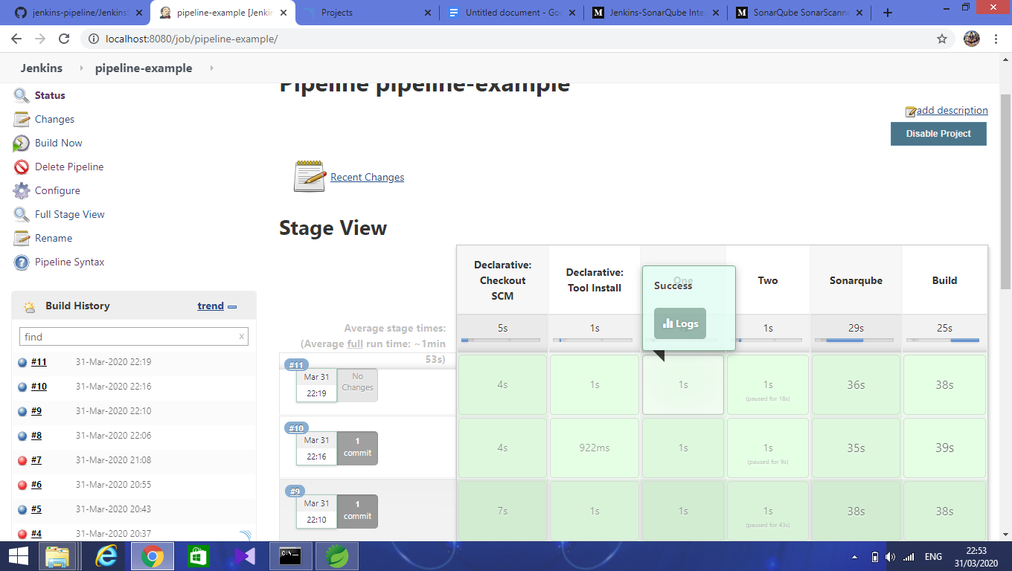

Console output for sonarqube build success as shown below:

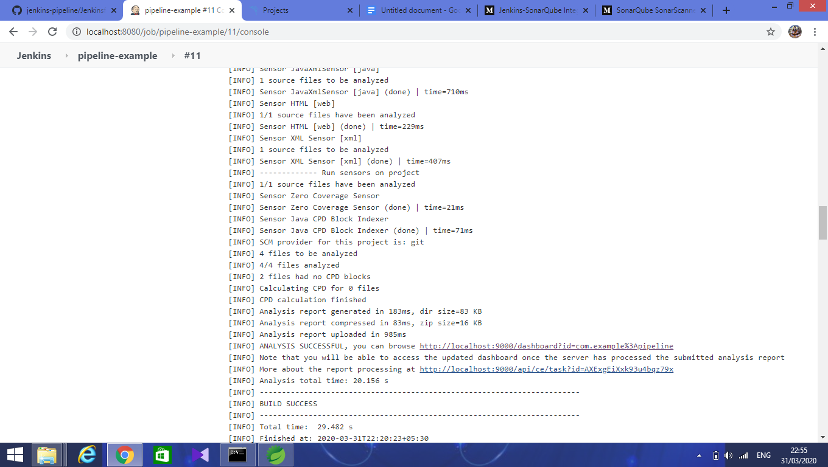

After the successful build, open the sonarqube dashboard <http://localhost:9000/projects> .

